Unit 8 Venn Diagram

Enlightenment:

American Revolution

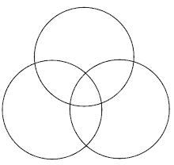

Latin American Revolution

French Revolution