What is Totalitarianism?

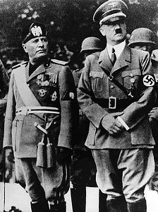Mussolini and Hitler

Totalitarianism is a form of government that exercises complete political, economic, social, cultural, and spiritual control over its subjects. A charismatic leader, or dictator, who controls the one allowable political party, usually heads it. This form of rule requires complete subordination of the individual to advance the interests of the state. People are made dependent on the wishes and whims of the political party and its leader. The government of Nazi Germany was an example of a Fascist, totalitarian state. Its ideology and practice included a racial theory that denigrated, persecuted, and murdered “non-Aryans,” particularly Jews. It also advocated extreme nationalism that called for the unification of all German-speaking peoples and required the centralization of decision-making by, and loyalty to, a single, all-powerful leader. The use of paramilitary secret organizations to stifle dissent and terrorize opposition ensured complete compliance. Information and ideas were effectively disseminated through government-controlled propaganda campaigns using radio, the press, and education at all levels. Writers, speakers, actors, composers, and poets were licensed and controlled by the government. The centrally controlled economy enabled the government to control its workers, making them dependent on the government. All workers were required to possess a work permit, which could be withdrawn for offenses such as objecting to poor working conditions. In a totalitarian dictatorship there is no legal means of effecting a change of government. Civil rights and human rights are not guaranteed.
What is Democracy?

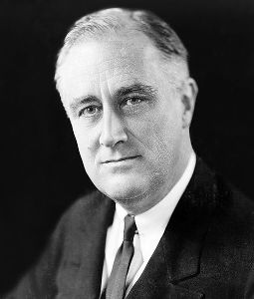President Roosevelt

Democracy is a system of government in which ultimate political authority is vested in the people. Representatives elected by popular suffrage (voting) exercise the supreme authority. In democracies such as the United States, both the executive head of government (president) and the legislature (Senate and House of Representatives) are elected. The powers of government are based on the consent of the governed. Groups or institutions typically exercise the democratic theory in a complex system of interactions that involve compromises and bargaining in the decision process. The major features of a modern democracy include government only by the consent of the governed, individual freedom guaranteed by a constitution, equality before the law, which maintains that all persons are created equal with minority rights protected, universal suffrage, and education for all. Citizens are free to join any political party, union, or other legal group if they choose. Elected representatives may be supplanted by the electorate according to the legal procedures of recall and referendum, and they are, at least in principle, responsible to the electorate. Citizens retain the right to alter or abolish a government that becomes destructive and form a new government. There are no paramilitary organizations sanctioned by the government to suppress those citizens who voice opposition to the government. The cornerstones of democracy are freedom of speech, freedom of assembly, freedom of the press, and freedom of religion.

