**Name: Date: Block:**

**Final Comprehensive Essay- Document-Based Question Technology**

This question is based on the accompanying documents. It is designed to test your ability to work with historical documents. Some of these documents have been edited for the purposes of this question. As you analyze the documents, take into account the source of each document and any point of view that may be presented in the document.

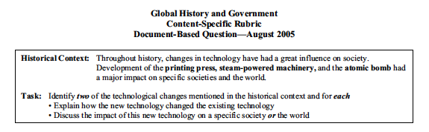

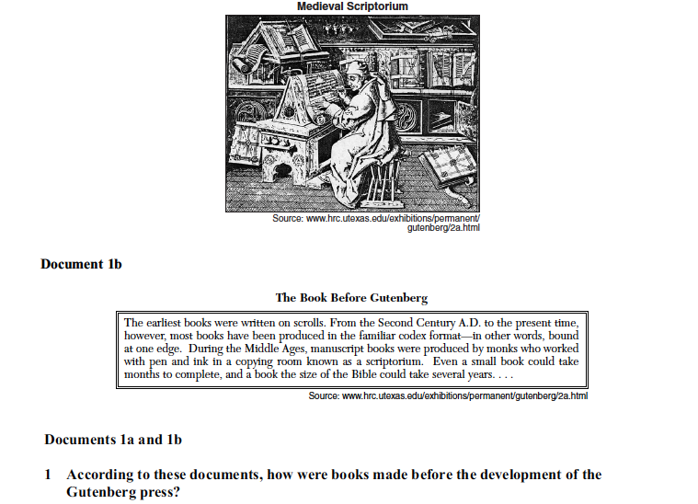

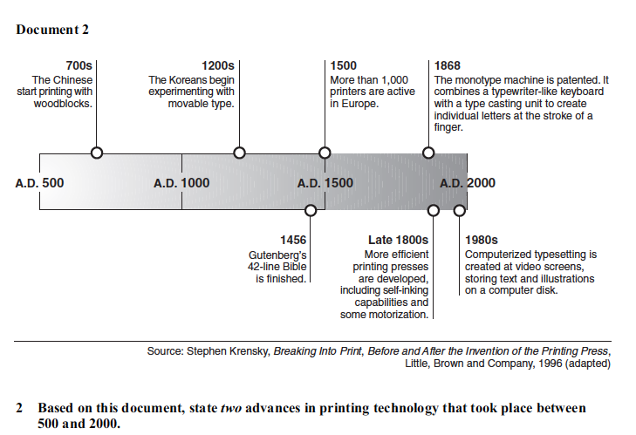

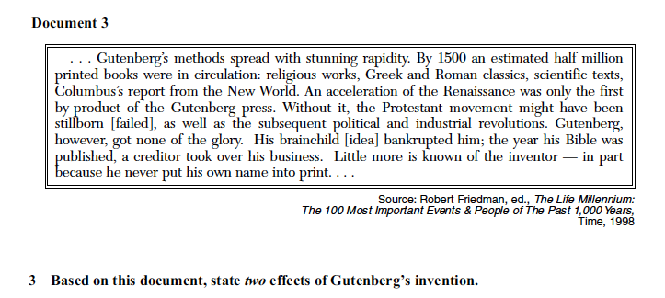

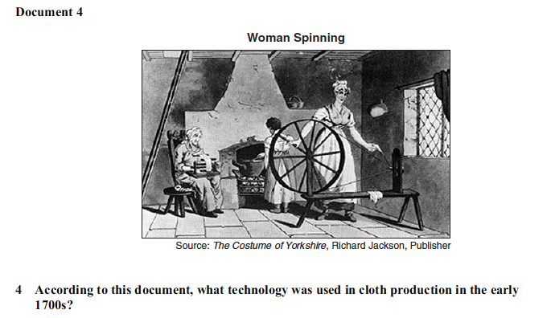

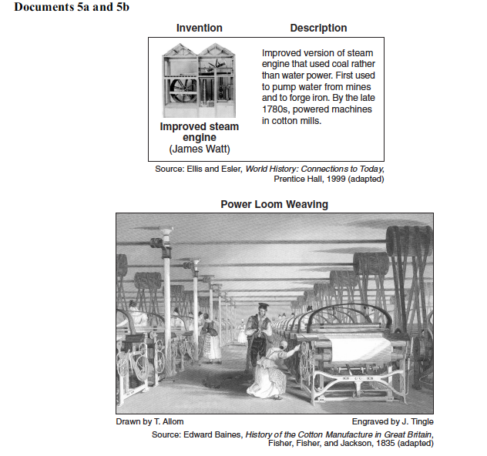

Macintosh HD:Users:jallen:Desktop:Screen shot 2013-05-09 at 6.43.03 AM.png

